This documentation contains how to get a result from an activity. Starting another activity and getting the result does not need to be a one-way operation. This can also be done by starting another activity and receiving the result from that activity in your current activity.

Here I am showing an example where one can click on the button to upload an image from the internal storage of the phone and that image will be displayed in the imageview.

## First make a new project in android.

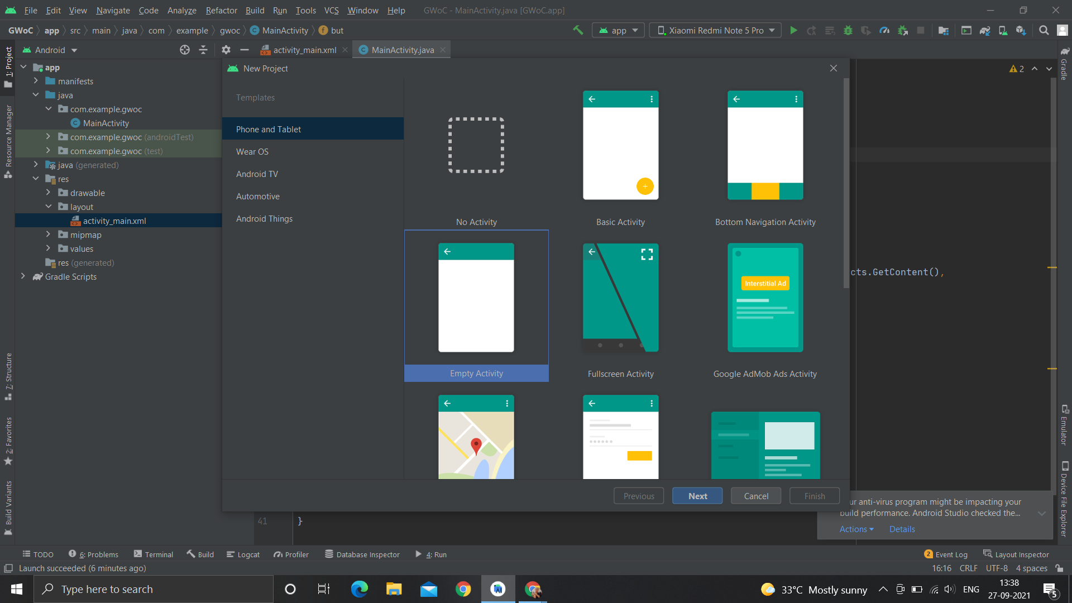

Give the name whatever you want and select the language java.

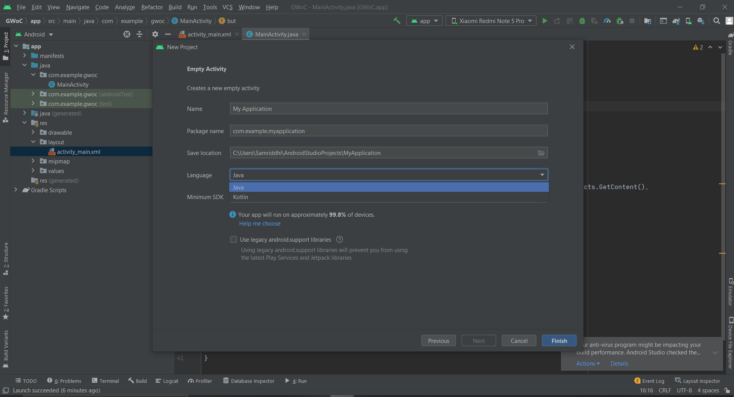

Now in layout set an ImageView and a button

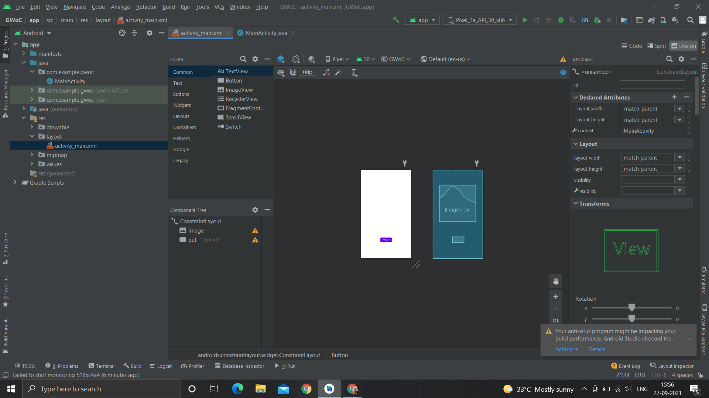

In java class define the ImageView and button variables then follow the steps listed below.

**Registering a callback for an Activity Result**

[registerForActivityResult()](https://developer.android.com/reference/androidx/activity/result/ActivityResultCaller#registerForActivityResult(androidx.activity.result.contract.ActivityResultContract%3CI,%20O%3E,%20androidx.activity.result.ActivityResultCallback%3CO%3E)) API is for registering the result callback while the image is selected. registerForActivityResult() takes an [ActivityResultContract](https://developer.android.com/reference/androidx/activity/result/contract/ActivityResultContract) and an [ActivityResultCallback](https://developer.android.com/reference/androidx/activity/result/ActivityResultCallback) where imageURI is set on the image, and returns an [ActivityResultLauncher](https://developer.android.com/reference/androidx/activity/result/ActivityResultLauncher) which will be used to launch the result .

An **ActivityResultContract** defines the input type needed to produce a result along with the output type of the result. Here the contract used is default([default contracts](https://developer.android.com/reference/androidx/activity/result/contract/ActivityResultContracts)) to take the picture, various contracts are there for different intent actions such as to take video to request multiple permissions and so on.

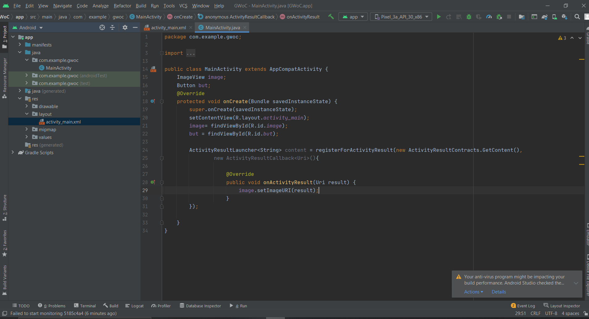

## **Launching an activity for result**

While registerForActivityResult() registers the callback, but does not launch the activity and rejects the request for a result. When onActivityResult() from the ActivityResultCallback is executed, calling launch() starts the process of producing the result.

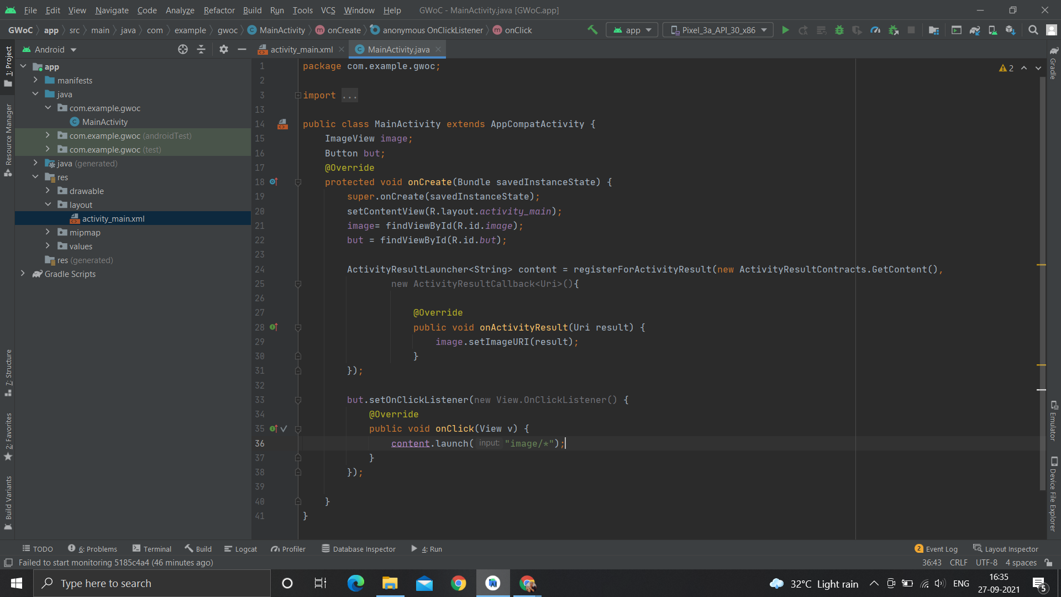

After uploading the image, in the activity result URI is received and the corresponding image is launched and shows up.

